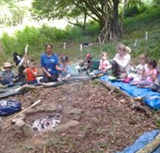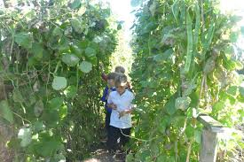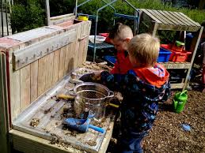

**HENNOCK COMMUNITY PRIMARY SCHOOL KEY IMPROVEMENT PRIORITIES 2018- 2019**

**Key Priority 2**

**Quality of Teaching**

To develop skills in life long and independent learning for pupils to achieve personal potential.

**Key Priority 3**

**Computing**

To set up and deliver a well-resourced and maintained computing curriculum that ensures a broad and balanced delivery of skills and experiences for pupils.

**Key Priority 4**

**Curriculum**

To develop a broad and balanced curriculum that caters for individual need and empowers pupils to tackle current world issues.

**Key Priority 5**

**Well-being and Mental Health Provision**

To raise the awareness of and act positively on issues surrounding mental health in pupils, staff and parents.

**Key Priority 6**

**Writing standards**

To develop strategies around writer purpose and raise standards for our higher attaining writers.

**Key Priority 1**

**Outcomes for Pupils**

To be at or above national progress for reading, writing and maths.

Improving the progress measures for non-disadvantaged children and previous high-attainers.