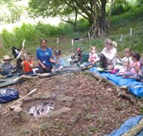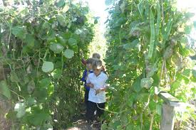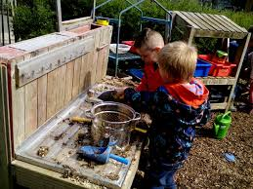

**HENNOCK COMMUNITY PRIMARY SCHOOL KEY IMPROVEMENT PRIORITIES 2017- 2018**

**Key Priority 2**

**Quality of Teaching**

Improve standards in spelling across the whole school with the introduction of a structured daily spelling investigation and tracking system that measures impact.

**Key Priority 3**

**Learning and Assessment**

To deepen understanding (mastery) of mathematical ideas by embedding the CPA progression. Undertake research into marking strategies, which support children’s mathematical reasoning.

**Key Priority 4**

**Personal Development and Welfare**

Enhance the scope and depth of teaching British Values, PHSE and SRE across the school through implementing the ‘Resilient Classroom’ program by Young Minds.

**Key Priority 5**

**Leadership and Management**

Recruit Governors and establish a governor program enabling them to continually update their knowledge of the school and address the impact it is having on pupils.

**Key Priority 6**

**Recruitment and Retention**

To increase numbers on roll by using effective marketing strategies and building relationships with the wider community.

**Key Priority 1**

**Outcomes for Pupils**

To be at or above the National Average in Reading, Writing and Maths at KS1 and KS2.

Increased number of greater depth writers at KS1 and KS2.