
Hennock Primary School: Calculation Policy 

Rationale:
It is our intent that children at Hennock Primary School learn mathematics by developing a deep conceptual understanding of number and calculation through using the concrete-pictoral-abstract (CPA) approach. This involves the use of physical resources, visual imagery and mathematical drawings/diagrams, which underpin children’s learning and allows them to make links across the maths curriculum. As conceptual understanding is being developed, children are shown and taught the abstract numbers, calculations, methods or techniques alongside, which allows them to use these successfully once their understanding is secure. This progression of understanding can take place within a single lesson, several lessons or over a longer period of time depending on the complexity of the content and the age phase and needs of the children. This progression of understanding is shown in this policy through the initials C (concrete) P (pictoral) and A (abstract).
The policy also states how children learn skills progressively from reception to year 6; this allows them to build effectively on the prior knowledge and conceptual understanding to allow them to master mathematical concepts. We define this as when children can:
- Describe it in his or her own words;
- Represent it in a variety of ways (e.g. using concrete materials, pictures and symbols)
- Explain it to someone else;
- Make up his or her own examples (and non-examples) of it;
- See connections between it and other facts or ideas;
- Recognise it in new situations and contexts;
- Make use of it in various ways, including new situations
(Adapted from John Holt ‘How Children Fail’ 1964)

Wherever possible, maths is taught with real life contexts so that children can link their own understanding of the world to their maths teaching and develop a good understanding of when maths is used and applied in real life.

ADDITION
 | Reception | Year 1 | Year 2 | Year 3 | Year 4 | Year 5 | Year 6
End of Year Group Expectations | Uses the language of ‘more’ and ‘fewer’ to compare two sets of objects.  Finds one more or one less from a group of up to five objects, then ten objects.  In practical activities and discussion, beginning to use the  vocabulary involved in adding and  subtracting.  Using quantities and objects, they add two single-digit numbers  and count on to find the answer.  Records, using marks that they can interpret and explain.  Begins to identify own mathematical problems based on  own interests and fascinations.  Learn number bonds to 5 and some bonds within 10. | Solve one-step problems that involve addition and subtraction, using concrete objects and pictorial representations, and missing number problems such as  7 = ☐ + 5  Read, write and interpret  mathematical statements  involving addition (+),  subtraction (–) and equals  (=) signs | Add and subtract numbers using concrete objects, pictorial representations, and mentally, including:  - a two-digit number and ones  - a two-digit number and tens  - two two-digit numbers  - adding three one-digit numbers  Add and subtract two two digit numbers using concrete objects, pictorial  representations progressing to  formal written methods | Add and subtract numbers mentally, including:  - a three-digit number  and ones  - a three-digit number  and tens  - a three-digit number  and hundreds  Add and subtract numbers  with up to three digits, using formal written methods of  columnar addition and  subtraction | Solve addition and  subtraction two-step  problems in contexts,  deciding which  operations and  methods to use and  why  Add and subtract  numbers with up to 4  digits using the formal  written methods of  columnar addition  where appropriate | Add and subtract  numbers mentally  with increasingly  large numbers  Add and subtract  whole numbers with  more than 4 digits, including beginning to add and subtract decimals  including using  formal written  methods (columnar  addition and  subtraction) | Perform mental  calculations,  including with  mixed operations  and large numbers  Add and subtract  decimal numbers  including using  formal written  methods  (columnar addition  and subtraction)
Key Vocabulary | Numbers names  More, add, and, count up, how many more?  Make, total, how many altogether?  Partition, composition, subitise | Place value, ones, tens,  Number bond, Plus, …. More (e.g. 10 more)  Equals, equals sign, is the same as, sum of  Part, whole, partition  Bar model | Addition, exchange, regrouping  Tens boundary | Hundreds  Inverse method  Vertical (column) method | Thousands  Increase (by) | Ten thousand, hundred thousand | Million
Mental Methods | Counting on songs, rhymes, games and with apparatus; muddy maths.  Counting practically on a large number line & a range of objects  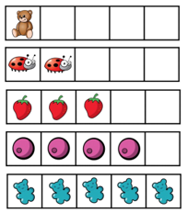 | Number bonds to ten (CPA: tens frame and numicon to support this)  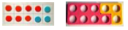  Count on in 1s (CPA: Bead strings, number lines support this) | Count on and back in 1s and 10s, and using number bonds (CPA: bead strings, 100 squares, and number lines support this)  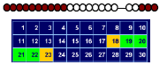  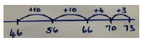 | Use place value to add numbers mentally  E.g. 243 + 431  200 + 400 = 600  40 + 30 = 70  3 + 1 = 4  Then mentally add the totals:  243 + 431 = 674  Efficiency: rounding and adjusting (compensating)  225 + 198 is the same as:  225 + 200 then – 2.  Number bonds to 100  46 + 54 = 100 | Use place value to add numbers mentally  E.g. 4243 + 7431  4000 + 7000 = 11000  200 + 400 = 600  40 + 30 = 70  3 + 1 = 4  Then mentally add the totals:  243 + 431 = 11674  Efficiency: adding on / bridging  5237 + 1028  Take 5237 + 1000 = 6237  6237 + 20 = 6257  6257 + 8 = 6265 | Use place value to add decimal numbers mentally  3.4 + 2.5 =  3 + 2 = 5  0.4 + 0.5 = 0.9  Then mentally add the totals:  5 + 0.9 = 5.9  Evaluating and comparing efficiency of mental methods such as rounding and adjusting, compensating, bridging and number bonds in specific context of a problem | Use place value to add decimal numbers mentally  6.34 + 5.04  6 + 5 = 11  0.3 + 0.0 = 0.3  0.04 + 0.04 = 0.08  Then mentally add the totals:  11 + 0.3 + 0.08 = 11.38
Developing Conceptual Understanding | Composition of number  C: Use real life objects and numicon to understand composition of number and to subitise numbers  =  Addition  Use Numicon for addition and without  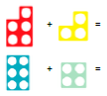  C: Use real life objects to count all and 1 more    P: Use pictures for number sentences | Bonds to and within ten and twenty  C: Combining two parts to make a whole (including adding 1 more) using Numicon, multilink and other representations, including counting on fingers. Balance scales used to represent the equals sign.  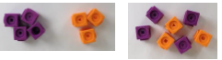  C: Moving on to a concrete bar model representation  C: Bridging the ten with tens frames and counters  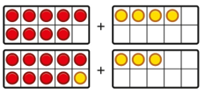  P: Bonds to and within ten and twenty  Draw part-part-whole diagrams  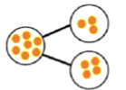  Drawn bar models  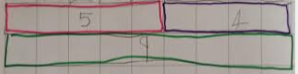  Drawn tens frames | Adding tens and ones  C: Use Base 10 to represent a calculation, including partitioning and exchanging both in vertical (columnar) and bar model representations  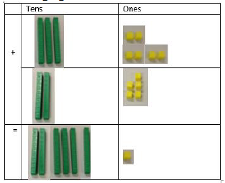  P: Drawn base 10 representations using vertical (columnar) layout  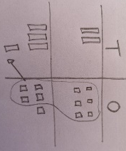  Bar model representations of calculations:  Some children will be ready to use more abstract Place Value counters to add – this is further covered in Year 3. | Adding hundreds, tens and ones  C: Use Base 10 and place value counters to represent calculations that include exchange  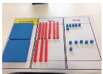  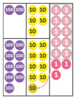  P: Pictoral representations of Base 10 and place value counters  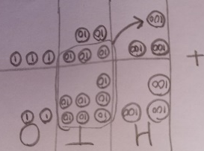  Bar model representations of calculations: | Adding thousands, hundreds, tens and ones  C: Use place value counters set out in vertical (columnar) method  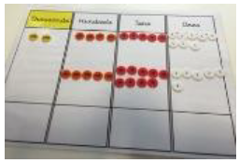  P: Drawn version of place value counters to support, if required.  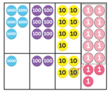  Some children may continue to use concrete and pictoral versions of base 10 to support calculations, if needed. | Adding increasingly large numbers  C: Place value counters support exchanges of tenths to ones  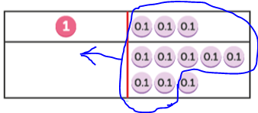  P: Drawn version of place value counters to support, if required. | Adding increasingly large numbers and decimals  CP: Place value counters and grids are used where prior knowledge is not secure or to underpin concepts.
  
  
  24 | 13
  37
  134 | 622
  756
Written Method (abstract) |  | Written number sentence:  6 + 3 = 9  3 + 6 = 9  9 = 6 + 3  9 = 3 + 6 | Written number sentence, including to show partitioning.  36 + 25 =  30 + 20 = 50  6 + 5 = 11  50 + 10 + 1 = 61  A: Vertical method for non-exchange calculations  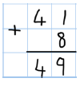  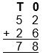 | Vertical (columnar) method, with exchange taking place below the equals bar:  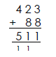 | Vertical (columnar) method, with exchange taking place below the equals bar:  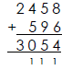 | Vertical (columnar) method, with exchange taking place below the equals bar.  Decimal place occupies its own place in the column.  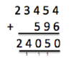  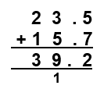 | Vertical (columnar) method, with exchange taking place below the equals bar.  Decimal place occupies its own place in the column.  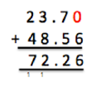

SUBTRACTION
 | Reception | Year 1 | Year 2 | Year 3 | Year 4 | Year 5 | Year 6
End of Year Group Expectations | Uses the language of ‘more’ and ‘fewer’ to compare two sets of objects.  Finds one one less from a group of up to five objects, then ten objects.  In practical activities and discussion, beginning to use the  vocabulary involved in adding and  subtracting.  Using quantities and objects, they subtract two single-digit numbers  and count back to find the answer.  Records, using marks that they can interpret and explain.  Begins to identify own mathematical problems based on  own interests and fascinations. | Solve one-step problems that involve addition and subtraction, using concrete objects and pictorial representations, and missing number problems such as  ☐ - 5 = 3  Read, write and interpret  mathematical statements  involving addition (+),  subtraction (–) and equals  (=) signs | Add and subtract numbers using concrete objects, pictorial representations, and mentally, including:  - a two-digit number and ones  - a two-digit number and tens  - two two-digit numbers  - adding three one-digit numbers  Add and subtract two two digit numbers using concrete objects, pictorial  representations progressing to  formal written methods | Add and subtract numbers mentally, including:  - a three-digit number  and ones  - a three-digit number  and tens  - a three-digit number  and hundreds  Add and subtract numbers  with up to three digits, using formal written methods of  columnar addition and  subtraction | Solve addition and  subtraction two-step  problems in contexts,  deciding which  operations and  methods to use and  why  Add and subtract  numbers with up to 4  digits using the formal  written methods of  columnar addition  where appropriate | Add and subtract  numbers mentally  with increasingly  large numbers  Add and subtract  whole numbers with  more than 4 digits, including beginning to add and subtract decimals  including using  formal written  methods (columnar  addition and  subtraction) | Perform mental  calculations,  including with  mixed operations  and large numbers  Add and subtract  decimal numbers  including using  formal written  methods  (columnar addition  and subtraction)
Key Vocabulary | Numbers names  Less, fewer, count back, take (away),  Leave, how many have gone? How many are left? | Subtract, minus, … less (e.g 10 less) | Subtraction, exchange, regroup  Difference | Round & adjust  Inverse method, estimate  Column method | Decrease (by)  Inverse method
Mental Methods | Counting back songs, rhymes, games and with apparatus; muddy maths.  Counting practically back a large number line & a range of objects e.g rocket take-off   | Number bonds to ten (CPA: tens frame and numicon to support this)  Count back in 1s (CPA: Bead strings, number lines support this) | Counting back in tens and ones  (CPA: hundred square to support) beginning in jumps of 1 or 10, then moving to more efficient jumps  Difference  Number sense to notice when to count on to find the difference:  72 – 68 = 4 | Counting back in hundreds, tens and ones  Mentally subtracting by counting back or making efficient jumps, beginning with ones.  Do not use partitioning.  Difference  Number sense to notice when to count on to find the difference:  302 – 297 = 5  Efficiency: rounding and adjusting  225 - 198 is the same as:  225 - 200 then + 2. | Same as year 3 mental methods but extending to 4 digit numbers. | Same as year 3 mental methods but extending to 5 digit numbers and decimals.  Identify opportunities to use mental fluency and evaluating efficiency of different mental methods | Same as year 3 mental methods but extending to increasingly large numbers and decimals.
Developing Conceptual Understanding | C: Use objects to count all and 1 less, moving on to bigger numbers  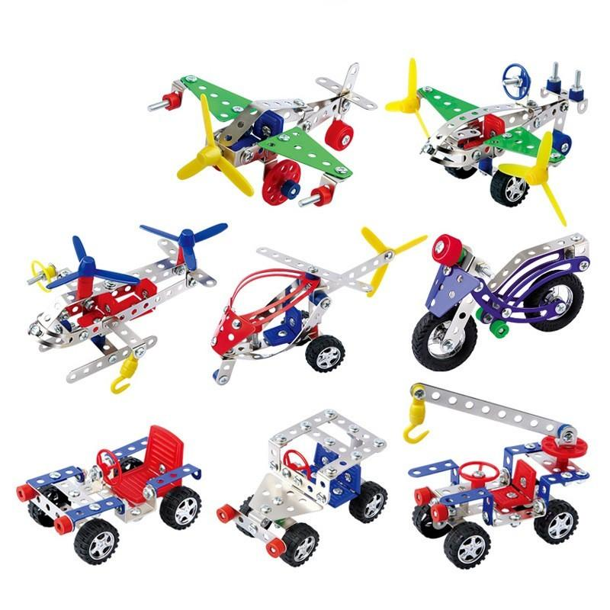  P: Use pictures to cross off to show one less  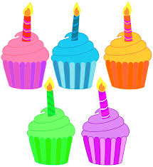 | Counting back  C: Physically counting out objects in a group, taking an amount away and then re-counting what is left.  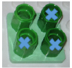  C: For 2-digit – 1-digit, partition first and then subtract parts.  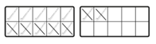  P: representing this pictorially by crossing out    and using tens frames for larger numbers  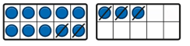  Finding the difference  C: Arrange two groups of objects with a difference:    The difference is two.  P: Represent using counters and base 10  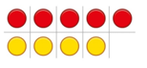  Bonds to and within ten and twenty (missing numbers)  C: Separating physical objects from a whole group into parts – how many are left?  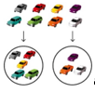  P: Represent as a part-part-whole diagram and bar models  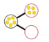 | Subtracting tens and ones  C: Use Base 10 on a place value grid, to count back and to exchange a ten for 10 ones, beginning with the ones column; number lines used to count back & partition.  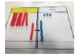  P: Drawn base 10 on place value grids, including crossing out to exchange beginning with the ones column:  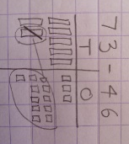  Use bar models to recognise difference and missing numbers: | Subtracting hundreds, tens and ones  C: Use Base 10 on a place value grid, including to exchange, beginning with the ones column  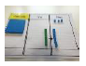  P: Drawn base 10 on place value grids, including crossing out to exchange beginning with the ones column:  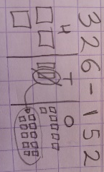  Bar models continue to be used to represent problems.  Some children will be ready to use more abstract Place Value counters to add – this is further covered in Year 4. | Subtracting thousands, hundreds, tens and ones  C: Use place value counters set out in vertical (columnar) method, then subtract beginning with ones column by taking counters away.  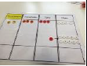  P: Drawn version of place value counters to support, if required.  Bar models continue to be used to represent problems.  Some children may continue to use concrete and pictoral versions of base 10 to support calculations, if needed. | Subtracting increasingly large numbers  CP: Use of concrete and pictoral phases if needed. | Subtracting increasingly large numbers and decimals  CP: Use of concrete and pictoral phases if needed.
  8
  6 | ?
  73
  ? | 46
Written Method (abstract) |  | Counting back / finding the difference  6 – 4 = 2  6 – 2 = 4  2 = 6 – 4  4 = 6 – 2  2 is 4 less than 6.  The difference between 6 and 4 is 2.  Bonds to and within ten and twenty (missing numbers)  A: written part-part-whole diagram with corresponding number sentence.  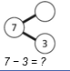  A: Understanding quads:  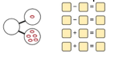  “If I know this, what else do I know?” | Subtracting tens and ones  A: Understanding commutativity:  12 + 23 = 35  23 + 12 = 35  35 – 12 = 23  35 – 23 = 12  A: Subtracting by bridging 10  63 – 27  63 – 7 = 56  56 – 20 = 36  63 – 27 = 36  A: Vertical method for non-exchange calculations  5 6  - 3 2  2 4 | Vertical (columnar) method, beginning with furthest right column, with exchange taking place as follows:  - recognise where exchange is needed (“we can’t swap the numbers”)  - go to the next column and cross out the number you need to exchange from.  - replace it above with a number that is one lower.  - put the exchanged digit, above and to left of the digit in the previous column  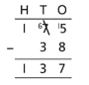 | Vertical (columnar) method beginning with furthest right column, with exchange taking place as taught in year 3.  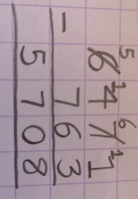 | A: Vertical (columnar) method, beginning with furthest right column, with exchange taking place as taught in year 3.  Decimal place occupies its own place in the column.  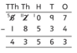 | A: Vertical (columnar) method, beginning with furthest right column, with exchange taking place as taught in year 3.  Decimal place occupies its own place in the column.  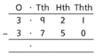

MULTIPLICATION
 | Reception | Year 1 | Year 2 | Year 3 | Year 4 | Year 5 | Year 6
End of Year Group Expectations | They solve problems, including doubling. | Solve one-step problems involving multiplication and division, by calculating the answer using concrete objects, pictorial representations and arrays with the support of the teacher  Encourage children to begin to write it as repeated addition in preparation for Year 2.  e.g. , 2+2+2+2=8 | Show that multiplication of two numbers can be done in any order (commutative) and division of one number by another cannot.  Solve problems involving multiplication and division, using materials, arrays, repeated addition, mental methods, and multiplication and division facts, including problems in contexts  Calculate mathematical  statements for multiplication within the  multiplication tables and write them using the multiplication (×), division  (÷) and equals (=) signs. | Write and calculate mathematical statements for multiplication and division using the multiplication tables that they know, including for two-digit numbers times one-digit numbers, using mental methods  Write and calculate mathematical statements for ÷ using the x tables they know progressing to  formal written methods. | Use place value, known and derived facts to multiply and divide mentally, including: multiplying by 0 and 1; dividing by 1; multiplying together three numbers  Recognise and use factor pairs and commutativity in mental calculations.  Multiply two-digit and three-digit numbers  by a one-digit number using formal written layout | Multiply and divide numbers mentally drawing upon known facts.  Multiply and divide whole numbers and those involving decimals by 10, 100 and 1000.  Identify multiples and factors, including finding all factor pairs of a number, and common factors of two numbers  establish whether a number up to 100 is prime  Multiply numbers up to 4  digits by a one- or two-digit number using a formal written method,  including long multiplication for two-digit  numbers | Perform mental calculations, including with mixed operations and large numbers  Multiply multi-digit numbers up to 4 digits by a two-digit whole
Key Vocabulary | Double | Count in  Array, row, column  Groups of, equal groups, unequal groups | Multiply, multiplied by, multiplication, times table  Product | Expanded method  Multiple | Product | Factor, factor pair, factorisation  Prime  Square, cube (numbers) | Lowest common multiple (LCM), highest common multiple (HCM), highest common factor (HCF)
Mental Methods | Counting in 2s using rhymes, practical activities and games.  Talking about pairs of practical items e.g. shoes, gloves, socks  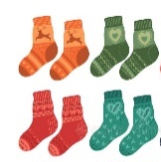 | Counting in 2s 5s and 10s using games, songs and rhymes. | Counting in 2s, 5s and 10s and begin 3s using games, songs and rhymes.  Using Times Tables Rock Stars to practice recall of above tables.  Checking strategies:  - 2x and 10x are always even  - 10x always has a ones digit of 0  - 5x table follow a 5, 0 ones digit repeated pattern | Counting in 3s, 6s and 4s and 8s using games, songs and rhymes.  Using Times Tables Rock Stars to practice recall of above tables.  Checking strategies:  - 4x, 6x and 8x are always even  - 3x table follow odd, even repeated pattern  - 6x is double 3x table  - 8x is double 4x table | Counting in 7s, 9s and 11s and 12s using games, songs and rhymes.  Using Times Tables Rock Stars to practice recall of above tables.  Checking strategies:  -12x are always even  - 12x is double 6x table  - 11x has a simple patter up to 9x11  - 9x table: finger trick to help, digits of products always add to 9  - 7x follow odd, even repeated pattern | Use times tables knowledge for 10x, 100x, 1000x bigger:  2 x 3 = 6  200 x 3 = 600 | Use times tables knowledge for 0.1x, 0.01:  4 x 6 = 24  4 x 0.6 = 2.4  4 x 0.06 = 0.24
Developing Conceptual Understanding | CPA: Doubling in context e.g. adding spots to a ladybird or using numicon.  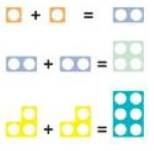 | Groups of 2s  C: Use concrete resources to count groups of twos, including numicon:  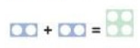  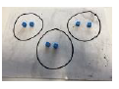  P: Pictoral representations of the above, moving on to drawing in an array structure and as a bar model with equal bars.   | Groups of 5s and 10s  C: Use concrete resources to count groups of twos, including numicon:    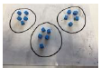  P: Pictoral representations of the above, moving on to drawing in an array structure in different orientations, and as a bar model with equal bars.   | Groups of 3s, 6s and 4s and 8s  C: Continue use of physical objects to support concept of groups of.  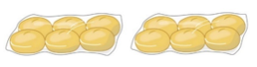  P: Pictoral representations as arrays.  Beginning to multiply a 2-digit by a 1-digit number  C: Use Base 10 to represent calculations using an expanded method, showing individual calculations at the side to develop understanding  24 X 3 =  P: Pictoral representation of base 10, if needed.  Some children at year 3 may be ready to represent this with place value counters as well. | Learn and know times tables up to 12 x 12  CP: Use of resources and drawings if needed to support understanding  Understand special cases of multiplying by 1 and 0  C: Use everyday resources to represent problem  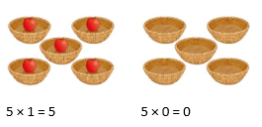  Multiply a 2-digit by a 1-digit number  C: Use expanded method with place value counters to solidify understanding of exchange.  P: Pictoral version if necessary  243 x 4  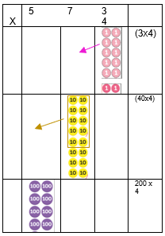 | Factors and primes  CP: Base 10 used if necessary  Multiplying numbers up to 4-digit x 2-digit  CP: Place value counters used if necessary | Multiplying numbers up to 4-digit x 2-digit, including decimals.  CP: Base 10 used if necessary
  6
  2 | 2 | 2
  15
  3 | 3 | 3 | 3 | 3
   | 2 | 3
  X |  | 4
   |  | 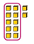 | (4x3)
   | 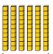 |  | (20x3)
Written Method (abstract) |  | Repeated addition number sentence:  2 + 2 + 2 = 6  Understanding multiplication:  “ 3 equal groups of 2 is 6”  Some children in year 1 may be familiar with the x sign and be able to understand its context in a number sentence. | Repeated addition number sentence:  5 + 5 + 5 + 5 = 20  Formal number sentence  5 x 4 = 20  4 x 5 = 20 | Number sentences:  3 x 4 = 12  48 = 6 x 8  Beginning to multiply a 2-digit by a 1-digit number  36 x 4 = 144 | Number sentences:  11 x 12 = 132  49 = 7 x 7  Multiply a 2-digit by a 1-digit number  Expanded method to begin with  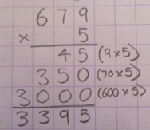  Leading on to formal method with exchange which takes place underneath:  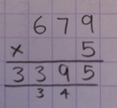 | Prime factorisation:  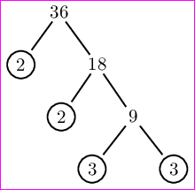  Multiplying numbers up to 4-digit x 2-digit  Formal method with exchange as follows:  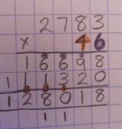 | Multiplying numbers up to 4-digit x 2-digit  Formal method with exchange as per year 5.
   | 3 | 6
  x |  | 4
   | 2 | 4 | (6 x 4)
  1 | 2 | 0 | (30 x 4)
  1 | 4 | 4

DIVISION
 | Reception | Year 1 | Year 2 | Year 3 | Year 4 | Year 5 | Year 6
End of Year Group Expectations | They solve problems including halving.  They solve problems including sharing.  Records, using marks that they can interpret and explain. | Solve one-step problems involving multiplication and division, by calculating the answer using concrete objects, pictorial representations and arrays with the support of the teacher  Encourage children to begin to write it as repeated addition in preparation for Year 2.  e.g. , 2+2+2+2=8 | Show that multiplication of two numbers can be done in any order (commutative) and division of one number by another cannot  Solve problems involving multiplication and division, using materials, arrays, repeated addition, mental methods, and multiplication and division facts, including problems in contexts  Calculate mathematical statements for multiplication within the  multiplication tables and write them using the multiplication (×), division  (÷) and equals (=) signs and begin to show remainders | Write and calculate mathematical statements for multiplication and division using the multiplication tables that they know, including for two-digit numbers times one-digit numbers, using mental methods  Write and calculate mathematical statements for ÷ using the x tables they know progressing to formal written methods with remainders included. | Use place value, known and derived facts to multiply and divide mentally, including: multiplying by 0 and 1; dividing by 1; multiplying together three numbers  Recognise and use factor pairs and commutativity in mental calculations  Continue to write and calculate mathematical statements for ÷ using the x tables they know progressing to formal written methods with remainders. | Multiply and divide numbers mentally drawing upon known facts  Multiply and divide whole numbers and those involving decimals by 10, 100 and 1000  Divide numbers up to 4 digits by a one-digit number using the formal written method of short division and interpret remainders appropriately for the context. | Perform mental calculations, including with mixed operations and large numbers  Divide numbers up to 4-digits by a two-digit whole number using the formal written method of short division where appropriate for the context
Key Vocabulary | Share  Half | Count in  Share, group, equally, equal groups of  Halve | Divide, divided by, division | Left over, remainder  Short division | Divisible by, divisor, quotient
Mental Methods | Understanding the notion of fairness and its application in equal sharing.  Halving in practical contexts e.g. halving cakes, sandwiches.  Finding two matching  Numicon pieces to make a whole number. | Counting in 2s 5s and 10s using games, songs and rhymes.  Halving & sharing in practical contexts e.g. sharing toys between two people; halving an apple | Counting in 2s, 5s and 10s and begin 3s using games, songs and rhymes.  Using Times Tables Rock Stars to practice recall of above tables.  Checking strategies:  I know that 2 x 6 = 12 so 12 ÷ 2 must equal 6 | Counting in 3s, 6s and 4s and 8s using games, songs and rhymes.  Using Times Tables Rock Stars to practice recall of above tables.  Checking strategies:  I know that 3 x 8 = 24 so 24 ÷ 3 must equal 8 and 24 ÷ 8 must equal 3 | Counting in 7s, 9s and 11s and 12s using games, songs and rhymes.  Using Times Tables Rock Stars to practice recall of above tables.  Using known facts  I know 24 ÷ 3 = 8 so 240 ÷ 3 = 80 | Use times tables knowledge for 10x, 100x, 1000x smaller:  2700 ÷ 3 = 900  270 ÷ 3 = 90  27 ÷ 3 = 9 | Use times tables knowledge for decimals  6 ÷ 3 = 2 so 0.6 ÷ 3 – 0.2
Developing Conceptual Understanding | CPA: Practical contexts for halving & sharing, e.g halving an apple, 3 children share 3 pencils and get 1 pencil each.  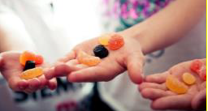 | Sharing  C: Sharing practical objects into equal groups  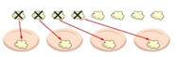  P: Pictoral representations of real life objects shared into groups  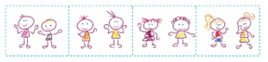  Making equal groups  C: Set amount of real life objects placed into equal groups  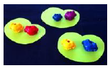  P: Drawn representations  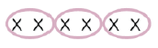  Bar models with equal parts | Sharing  C: Sharing practical objects into equal groups  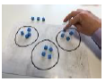  P: Pictoral representations of concrete resources shared into groups.  Making equal groups  C: Set amount of real life objects placed into equal groups  P: Arrays to show groupings    3 groups of 5  5 groups of 3  Bar models showing equal parts | Understanding remainders  C: Sharing objects into equal groups & recognise when there are some left over.  E.g. 19 ÷ 3 = 6r1    P: Pictoral representation of dividing circles in to groups.  Dividing a 2-digit number by 1-digit number (times table linked or just beyond)  C: Shown alongside written method, use Base 10 to partition number into tens and ones. Group tens by divisor, then exchange any remaining tens for ones. Group ones equally by divisor.  42 ÷ 3 = 14  P: Pictoral representation of the above. | Dividing a 2-digit or 3-digit number by 1-digit number, including with remainders  C: Shown alongside written method, as per year 3 method, use Base 10 to partition number into hundreds, tens and ones. Group hundreds by divisor and exchange any remaining, then group tens by divisor, then exchange any remaining tens for ones. Group ones equally by divisor.  E.g. 612 ÷ 3 = 104  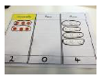  P: Pictoral representation of the above, if needed. | Dividing up to a 4-digit number by 1-digit number, including with remainders  CP: Use resources shown in year 4, if necessary. | Divide numbers up to 4-digits by a two-digit whole number  CP: Use resources shown in year 4, if necessary.
  6
  2 | 2 | 2
  15
  3 | 3 | 3 | 3 | 3
  T | 0
  1  1 group of 3 tens | 4  4 groups of 3 ones

Written Method (abstract) |  | “10 shared into 2 equal groups gives 5 in each group.”  “10 grouped into 2s equals 5 groups in total” | Number sentences:  15 ÷ 3 = 5  15 ÷ 5 = 3 | Number sentences:  24 ÷ 3 = 8  24 ÷ 8 = 3  15 ÷ 4 = 3r3  Formal method of short division  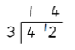 | Number sentences:  121 ÷ 11 = 11  7 = 63 ÷ 9  Formal method of short division  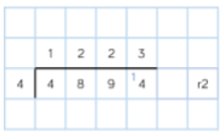 | Formal method of short division  Begin to show remainders as fractions.  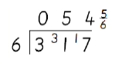 | Formal method of long division  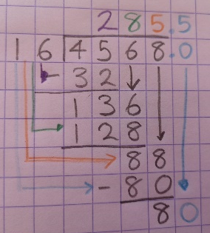

FRACTIONS, DECIMALS, PERCENTAGES AND RATIO
 | Reception | Year 1 | Year 2 | Year 3 | Year 4 | Year 5 | Year 6
Expectations | They solve problems including halving. | Recognise, find and name a half as one of two equal parts of an object, shape or quantity. Recognise, find and name a quarter as one of four equal parts of an object, shape or quantity.  Children should begin to explore finding simple fractions of objects, numbers and quantities. | Counting in fractions up to 10, starting from any and using the 1/2 and 2/4 equivalence on the  number line.  Write simple fractions for example ½ of 6 = 3 and recognise the equivalence of 2/4 and ½. Begin to relate multiplication and division models to fractions and measures.  Children should be given opportunities to find a half, a quarter and a third of shapes, objects, numbers and quantities.  Finding a fraction of a number of objects to be related to sharing. They will explore visually and understand how some fractions are equivalent – e.g. two quarters is the same as one half. | Count down in tenths; recognise that tenths arise from dividing an object or number into 10 equal parts.  Recognise and show using diagrams, equivalent fractions with small denominators.  Recognise, find and write fractions of a discrete set of objects: unit fractions and non-unit fractions with small denominators.  Addition & subtract fractions with the same denominator within one whole. | Recognise and show, using diagrams, families of common equivalent fractions  Count up and down in hundredths; recognise that hundredths arise when dividing an object by one hundred and dividing tenths by ten.  Solve problems involving increasingly harder fractions to calculate quantities, and fractions to divide quantities, including non-unit fractions where the answer is a whole number  Add and subtract fractions with the same denominator  Recognise and write decimal equivalents of any number of tenths or hundredths  Recognise and write decimal equivalents | Compare and order fractions whose denominators are all multiples of the same number  Recognise mixed numbers and improper fractions and convert from one form to the other and write mathematical statements > 1 as a mixed number  Add and subtract fractions with the same denominator and denominators that are multiples of the same number  Multiply proper fractions and mixed numbers by whole numbers, supported by materials and diagrams  Recognise the per cent symbol (%) and understand that per cent relates to ‘number of parts per hundred’, and write percentages as a fraction with denominator 100, and as a decimal  Solve problems which require knowing percentage and decimal equivalents and those fractions with a denominator of a multiple of 10 or 25 | Use common factors to simplify fractions; use common multiples to express fractions in the same denomination  Compare and order fractions, including fractions > 1  Add and subtract fractions with different denominators and mixed numbers, using the concept of equivalent fractions  Multiply simple pairs of proper fractions, writing the answer in its simplest form  Divide proper fractions by whole numbers  Associate a fraction with division and calculate decimal fraction  equivalents for a simple fraction
Key Vocabulary | Half | Equal parts, whole  Half, quarter, | Fraction  Third, three quarters  ‘of’ (half of) | Numerator, denominator  Tenth, sixth, eighth (& other fraction names)  Equivalent, equivalence  Unit fraction, non-unit fraction | hundredth  decimal, decimal equivalence  mixed-number fraction | Proper/improper fractions  Percent, percentage, % | Ratio, proportion
Mental Methods |  | Halving & sharing in practical contexts e.g. sharing toys between two people; halving an apple | CPA: Number lines to support counting in fractions. | CPA: Number lines to support counting in fractions. | CPA: Number lines to support counting in fractions.  Quick recall of simple decimal equivalents | Quick recall of key decimal equivalents
Developing Conceptual Understanding | As per ‘division’ for Reception. | C: Sharing an object into simple, equal parts.  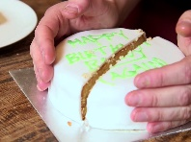  P: Simple pictoral representatons  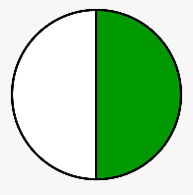 | Writing & understanding simple fractions:  C: Real life objects split into equal parts – noticing that x parts make a whole and this represents the denominator; exploring fraction walls    P: Pictoral representations, moving into a bar model:   Fractions of a number:  C: Finding a fraction of an amount of objects, e.g. counters    P: Drawn version of concrete, using a circle to show group. | Fractions of a number:  C: Find fractions of a real life objects, link to division e.g. ¼ of 20 counters = 20 ÷ 4  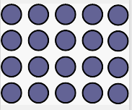  P: Pictoral representations of above, moving into bar model:  Simple equivalence:  C: Folding number strips; cuisinere rods, cutting fraction walls to show that two fractions can equal the same amount.  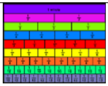  P: Bar model equivalent:  Adding and subtracting:  C: Fraction walls to count (add up)  P: Bar model with colours  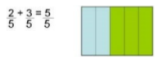 | Fractions of a number:  CP: As per year 4, with more complex fraction moving quickly into understanding the link to division.  E. ¾ of 20=  Equivalent fraction families:  C: As per year 3 but recognise there many fractions that can equal another fraction.  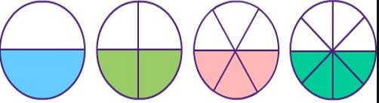  P: Bar model:  Adding and subtracting:  As per year 3, but quickly moving to abstract phase, identifying why the denominator does not CP: change but the numerator does. | Multiplying fractions by a whole number:  C: Cut fraction walls to recognise, beginning with thinking about ‘lots of’ e.g. ½ x 3 = 3 lots of ½  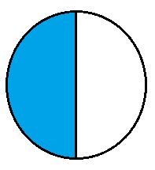  Moving on to composite version:  P: Drawn version of the above. | Multiplying fractions by fractions.  C: Use paper shapes & fraction walls to investigate  e.g ¼ x ½ = 1/8  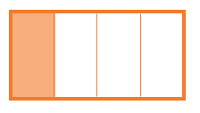  P: Drawn version of the above.  Dividing fractions by whole numbers  C: Real life context with paper shapes/cut fraction wall e.g “If a third of a pizza was shared between two people = 1/3 ÷ 2  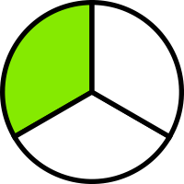  P: Drawn version of the above.  Ratio  C: Use real life objects to understand ratio & to solve problems  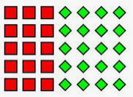  P: Bar models  e.g. The ratio of red to green is 1:2. How many green blocks are there in a bag of 6 blocks.
  20
  ? | ? | ? | ?
  1/2 |  | 1/2
  ¼ | ¼ | ¼ | ?
  ½ |  |  |  | ½
  ¼ |  | ¼ |  | ¼ |  | ¼
  ? | ? | ? | ? | ? | ? | ? | ?
  6
Written Method (abstract) | As per ‘division’ for Reception. | “I’ve got one half and you have one half.” | ½ means one part out of 2 in total. | 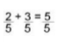  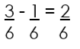 | ¾ of 20 = 15  (We know ¼ is 5, so 3 lots of 5 = 15)  $\frac{3}{8}$ + $\frac{5}{8}$ = $\frac{7}{8}$ | $\frac{3}{8}$ + $\frac{3}{4}$ =1 $\frac{1}{8}$  ½ x 3 = 1 ½ | ¼ x ½ = 1/8  1/3 ÷ 2 = 1/6

