Welcome to the Link Academy Trust
We have designed this recruitment pack to give you an insight into our Trust, the academies within it and how you can become part of it by working with us.
The Link Academy Trust incorporates the sixteen small schools of Bearnes in Newton Abbot, Broadhempston, Cheriton Bishop, Diptford, Drake's, Harbertonford, Hennock, Ilsington ,Landscove, Morchard Bishop, Moretonhampstead, Otterton, Stoke Gabriel, Tedburn St Mary, Widecombe-in-the-Moor and Yeoford. Five of the schools are situated in rural villages around the town of Totnes, set within the beautiful South Hams region of Devon. Hennock, Ilsington, Moretonhampstead and Widecombe-in-the-Moor are on Dartmoor near Bovey Tracey. Bearnes Primary is set within the heart of Newton Abbot, Cheriton Bishop, Tedburn St Mary , Yeoford and Morchard Bishop are in the area just to the north east of Dartmoor, near Crediton and Drake's and Otterton are situated in Budleigh Salterton.
Whilst all the Academies gain expertise by work closely together, each school is unique with its own particular character and each Hub of schools, Totnes, Moorland, Raleigh and Woodleigh, have their own School Board. Our Academies achieve high academic standards through the provision of an exciting curriculum that makes the most of our rich surroundings. We offer a caring, nurturing environment, with dedicated staff who strive to meet the needs of every child and a culture of high expectations through first rate systems and procedures that ensure we are effective and efficient in all that we do.
Working together, our Academies can achieve more for our children than by working alone. We learn together, support each other, share our expertise and ensure we are always current, ready to offer the very highest standards of teaching and provide exceptional learning opportunities for all our children.
The Academies within our Multi-Academy Trust are vibrant and exciting places to work in, yet our small size enables us to know every child and build strong relationships with each family. All Academies have good reputations built on high standards and a caring ethos, but we are always looking for ways to improve so that we meet the challenges of preparing children for the future.
We maintain excellent links with other schools in the area and we have close ties with the successful local secondary schools of Ivybridge, Kingsbridge, South Dartmoor, Totnes, Newton Abbot, Teign, Exeter, Okehampton and Crediton as well as with the grammar schools in Torbay and Plymouth.
We look forward to receiving your application
Nicky Dunford, CEO

Our Academies

Bearnes is situated in the centre of the busy market town of Newton Abbot. The pupils of the school are encouraged to benefit from and respect the diversity of their environment, learning through educational opportunities from the locality and being involved with the community at all levels. The school has a strong ethos of self- fulfilment for the pupils, while of equal importance is the development of a caring and nurturing attitude to life. All the staff endeavour to provide all children with a safe and secure environment that has high expectations and supports them to fulfil their potential.
Broadhempston is a traditional small village school, bijou but perfectly formed, with a warm and friendly family atmosphere. Situated just a short distance from Totnes, making the most of the idyllic rural setting throughout the year. The school offers an exciting and relevant curriculum which provides excellent opportunities and experiences and great foundations for life. Whilst focussing on the highest academic achievement, they always have the ‘whole’ child in mind and have an excellent team of inspirational staff who help the children develop into positive and enthusiastic learners.
Cheriton Bishop is vibrant school with a warm and friendly family atmosphere who believe their pupils should clearly understand their responsibility for learning by actively engaging with the creative curriculum. They are encouraged to value their educational opportunities and enjoy the learning experiences it provides. In return they offer an excellent team of staff who work incredibly hard to provide a broad range of activities and challenges, whilst greatly valuing and actively promoting the partnership between home and school because they understand that it is only through joint support that every child will reach their full potential.
Diptford is a thriving and vibrant school, yet their small size enables them to know every child in real depth; to understand their talents and what motivates them. The staff aim to help every child discover their unique and individual potential and support them to develop it. Offering a caring, nurturing environment with a unique family atmosphere, the school has an excellent reputation and achieves high academic standards through the provision of a rich and exciting curriculum that makes the most of its beautiful surroundings.

Drake’s is very special school, where a dedicated emphasis on teaching and learning to high standards sits comfortably alongside the provision of a safe and happy space for their children to learn and develop as rounded, vibrant individuals. The school is also a valuable part of the community offering an excellent environment for all children and they believe in supporting all pupils to enable and inspire them to grow as confident, independent learners, fully equipped and ready for life’s challenges.

Harbertonford is a thriving small Church School situated just outside the town of Totnes and achieves high academic standards through the provision of an exciting curriculum that makes the most of its beautiful surroundings and caring, nurturing environment. It is a vibrant and exciting place aiming to help its pupils to discover their potential and enable them to fulfil it, whilst valuing their individuality and developing the whole child. Harbertonford has a good reputation, built on high standards and a caring ethos and they strive to meet the challenges of preparing children for the future, instilling a lifelong love of learning on the way.

Hennock is vibrant school with a warm and friendly family atmosphere. Situated on the doorstep of Dartmoor, they make the most of their idyllic rural setting throughout the year and work in close partnership with parents and the community. Learning effectively happens most successfully when children feel happy, safe and actively involved with purposeful experiences. Hennock aims to ensure children believe in themselves, trust those supporting them and are provided with inspirational learning experiences.
Ilsington is a small rural school nestling in the Devon countryside on the edge of Dartmoor with an integrated pre-school working alongside the primary classes, ensuring the highest standard of transition as the children reach primary age. Ilsington has a long history of providing a warm, caring, and creative environment where all children are welcome and where they are encouraged to be independent, active learners. The school’s culture is firmly rooted in its Christian values of Friendship, Kindness, Honesty, Resilience, Respect and Compassion.
Landscove is a thriving small church school, surrounded by rolling fields and farms. Well known for creating a safe and secure learning environment where all the children can grow and flourish. The children are given lots of learning opportunities outside the classroom and exciting experiences in all areas of the curriculum. Landscove has an excellent reputation built on high standards and a caring ethos with staff experienced and committed to meeting the individual needs of every child.

Morchard Bishop plays an active role in the village, supporting events such as: Open Gardens, the Flower Festival and Christmas Fairs and has a number of unique features such as: a Handbell team, a Roundhouse for forest School work and a kitchen garden. Every child deserves a rich variety of experiences and opportunities while at school and they aim to develop their love for learning through an engaging curriculum which is both broad and balanced. The teachers help each child develop this through stimulating lessons and challenging tasks.
Moretonhampstead is a vibrant school with a warm and friendly family atmosphere. They have kind, curious and engaged children and a staff team who are highly dedicated and strive to do the very best for every child. The school enjoys a positive relationship with parents and the local community and are fortunate to have a superb modern school building with excellent facilities and spacious grounds and outdoor spaces, nestled within Dartmoor National Park.

Otterton is in a beautiful village in the heart of East Devon. It is a special place where there is a tremendous amount of academic and lifelong learning brought to pupils through a carefully planned curriculum and a dynamic and dedicated teaching staff. It is a very family orientated and child-centered school, with a whole range of skills and experiences for pupils to develop their learning and unique abilities. An important part of the community with much activity taking place in our wonderful environment.
Stoke Gabriel is a thriving friendly school in the wonderful South Hams which has been designated an Area of Outstanding Natural Beauty. Achieving high academic standards through the provision of an exciting curriculum that makes the most of its beautiful surroundings, a caring, nurturing environment with a family atmosphere and a team of dedicated staff. A vibrant and exciting place to work in, yet their small size enables them to know every child and the things that motivate them.

Tedburn St Mary prides itself on being a warm, close-knit school with high educational expectations and standards, appreciating the varying needs and strengths of all pupils, helping them to achieve their full potential. They are committed to providing every pupil with the best possible educational experience within a safe, nurturing environment. Developing, encouraging and motivating children to ensure all pupils become confident and successful lifelong learners.

Widecombe is placed in a unique and beautiful location in the heart of Dartmoor. A sense of community is central to their ethos and they want all children to value and understand, not only their own school community and the surrounding local communities, but also extremely important that they develop a wider sense of what community means globally. At Widecombe, the curriculum gives frequent and varied opportunities for the children to develop their personal voice, meaning they leave Widecombe as confident, competent individuals.

Yeoford is an integral part of the village and community and they pride themselves on providing a safe, secure and friendly environment for every child to achieve their true potential. They enjoy a good range of resources, including their own football pitch, netball court and children's kitchen. The children also have their own allotments and achieve great success and enjoyment growing vegetables and then cooking them. Everything done at Yeoford is to provide every child with the best possible learning experience so it will
inspire, encourage and motivate them to become successful lifelong learners.

Work for Us

The Vacancy
Teaching Assistant Vacancies – Hennock Primary School
Wanted to join our successful and caring team, we require 3 Teaching Assistants for the following posts:-
1 Full time general TA Monday – Friday
2 Part time TA’s to work 3 days with some 1:1 support and general class TA responsibilities
All the above will have a mealtime assistant duty as part of their day
TA paid at Grade C £9.99ph and MTA paid at Grade A £9.50ph

We are looking for candidates with a strong, sensitive and caring approach to children’s needs, who can be flexible and is able to be an effective communicator and think creatively.
The Link Academy Trust offer you the support of clear systems, protocols, expectations and structures to help you to succeed. You will need to show initiative, creativity and demonstrate the aptitude to work as part of a successful and growing team in Early Years to improve the life chances of our pupils and make every child feel ‘special’.
We want you to come and join our happy, positive learning environments where our consistent vision is that through collaboration we will always be ‘Stronger Together’.
Ideally, you will:
- Have excellent literacy and numeracy skills;
- Be able to build positive relationships with children, staff and parents;
- Have high expectations of children’s behaviour and be able to maintain consistent boundaries;
- Be willing to work as part of a team;
- Be able to use your own initiative when required;
- Have experience in a similar role in a school;
You should have English and Maths to GCSE A-C or equivalent.
We are committed to safeguarding and promoting the welfare of children and young people and expect all staff to share this commitment. This post is subject to an enhanced DBS disclosure.
Visits to the school are encouraged. Please call the school administrator on 01626 833233 to arrange a convenient appointment.
To download an application form, please see the school website https://www.hennock.thelink.academy/website/vacancies/394227
Completed applications should be emailed direct to the Trust HR Officer, Sue Howard at hr@thelink.academy
Please specify when returning your application, which post you wish to be considered for.
Closing date: 10th October 2022
Interview date: 17th October 2022

The Role

POST DETAILS

TITLE Teaching Assistant

LINE MANAGER Executive/Academy Head

GRADE C

PURPOSE OF JOB

To work under the instruction/guidance of teaching/senior staff to undertake work/care/support programmes, to enable access to learning for pupils and to assist the teacher in the management of pupils and the classroom. Work may be carried out in the classroom or may regularly take place outside the main teaching area.

MAJOR RESPONSIBILITIES

To work under instruction/guidance to enable access to learning by:

- Attending to the welfare and personal care of pupils including those with special educational needs
- Delivering pre-determined learning/care/support programmes
- Implementing literacy/numeracy programmes
- Assisting with the planning cycle if required
- Undertaking general clerical/administrative support for the teacher/department

DUTIES

Support the teacher by:

- Creating and maintaining a purposeful, orderly and supportive environment, in accordance with lesson plans
- Assisting with the display of pupils work
- Using strategies, in liaison with the teacher, to support pupils to achieve learning goals
- Assisting with the planning of learning activities on a regular basis
- Monitoring pupils responses to learning activities and accurately recording achievement/progress as directed
- Providing detailed and regular feedback to teachers on pupils’ achievement, progress, problems etc.
- Promoting good pupil behaviour, dealing promptly with conflict and incidents in line with established policy and encouraging pupils to take responsibility for their own behaviour
- Establishing constructive relationships with parents/carers and where appropriate participating in feedback sessions with parents alongside the teacher
- Administering routine tests and undertaking routine marking of pupils work
- Providing clerical/administrative support e.g. photocopying, typing, filing, money, administration of course work etc.

Supporting pupils by:

- Supervising and providing particular support for pupils, including those with special needs, ensuring their safety and access to learning activities
- Assisting with the development and implementation of Individual Education/Behaviour Plans and Personal Care Programmes
- Establishing constructive relationships with pupils and interacting with them according to individual needs
- Promoting the inclusion and acceptance of all pupils
- Encouraging pupils to interact with others and to engage in activities led by the teacher
- Setting challenging and demanding expectations and promoting self-esteem and independence
- Providing feedback to pupils in relation to progress and achievement under the guidance of the teacher

Support the curriculum by:

- Undertaking structured and agreed learning activities/teaching programmes and adjusting activities according to pupil responses
- Undertaking programmes linked to local and national learning strategies e.g. literacy, numeracy, early years, recording achievement and progress and feeding back to the teacher
- Supporting the use of ICT in learning activities and developing pupils competence and independence in its use
- Preparing, maintaining and using equipment/resources required to meet the lesson plans/relevant learning activity and assisting pupils in their use

Support the academy by:

- Being aware of and complying with policies and procedures relating to child protection, health, safety and security, confidentiality and data protection, and reporting all concerns to an appropriate person
- Being aware of and supporting difference and ensuring all pupils have equal access to opportunities to learn and develop
- Contributing to the overall ethos/work/aims of the academy
- Appreciating and supporting the role of other professionals
- Attending relevant meetings as required
- Participating in training and other learning activities and performance development as required
- Assisting with the supervision of pupils out of lesson times, including before and after school and at lunchtimes as required
- Accompanying teaching staff and pupils on visits, trips and out of school activities as required and taking responsibility for a group under the supervision of the teacher

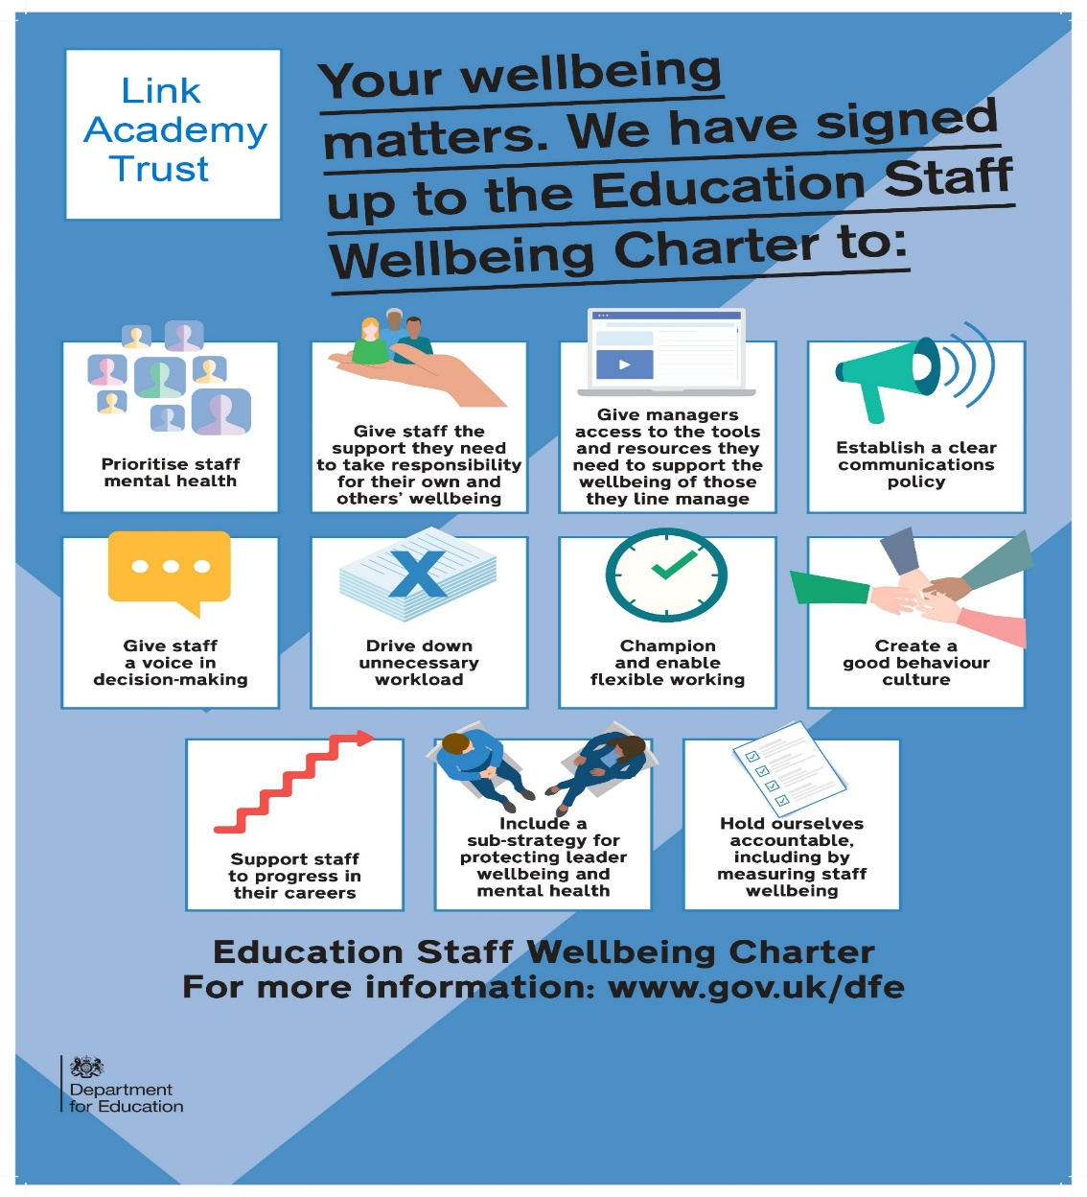

Link Academy Trust - Company Number 10049068

Registered Office Address - Landscove School, Landscove, Ashburton, Newton Abbot, Devon.TQ13 7LY

Tel:- 01803 762113 Email:- hr@thelink.academy
https://www.thelink.academy/web

